EARLY WARNING BULLETIN FOR FOOD SECURITY

No. 2014/14 IN THE GAMBIA Period: September 11-20, 2014

 Government of The Gambia | Produced and Published by The Gambia National Multidisciplinary Working Group  Focal Point: Department of Water Resources  TEL: (+220) 4227631 / 4224122 / 8905229 - FAX: (+220) 422 50 09  E-MAIL: dwr@mofwrnam.gov.gm / WEB: www.mofwrnam.gov.gm | 

1.0 METEOROLOGICAL SITUATION

1.1. SYNOPTIC SITUATION

On average, the surface positions of the ITD ITD (imaginary boundary line separating northern cold dry winds from southern warm moist winds) fluctuated over southern Mauritania, stretching towards northern Mali, sloping onto southern Algeria, central Mali and onto Chad.
Rain and thunderstorms characterized the weather over the Senegambia region, Burkina Faso, Ivory Coast, Ghana, Benin and Guinea Conakry during the period. Dust haze / sand storm occurred over Mauritania and Algeria with visibility ranging from 4000- 1000m.

1.2 WEATHER SUMMARY FOR THE GAMBIA

High humidity couple with scattered thunderstorms and moderate to heavy rain accompanied with strong winds traversed the country during the early and middle parts of the dekad.

1.3 WEATHER OUTLOOK FOR THE NEXT DEKAD (21st – 30th September 2014)

Variably cloudy to cloudy condition with scattered thunderstorms with rain sometimes squally is expected across the country during the dekad.

2.0 AGROMETEOROLOGICAL SITUATION

2.1 RAINFALL SITUATION

The rainfall situation continued to improve across the country, however there are some areas that are still lacking behind in terms of rainfall quantities. In the Western Third, dekadal totals varied from 84.0mm (highest) over Sibanor to 54.8mm over Yundum Airport. In the Middle Third dekadal totals varied between 126.7mm (highest) over Sapu to 108.9mm over Kaur. In the Eastern Third dekadal totals were 111.6mm and 100.1mm over Basse and Fatoto respectively. (Figure 1a).

Seasonal rainfall amounts recorded as of 20th September still depict variations in recorded rainfall amounts over various regions. In the Eastern Third seasonal totals were 762.0mm (highest) countrywide over Basse and 664.7mm over Fatoto. In the Middle Third, Sapu recorded the highest of 574.7mm; Kaur recorded the lowest seasonal total (392.9) in this region. In the Western Third, Sibanor recorded 753.0mm highest in the region, Banjul recorded 378.7mm. (Figure1b).

Figure 1a: Rainfall dekadal totals 11th –20th September 2014.

Figure 1b: Rainfall Seasonal totals from May 1st 2014 – September20th 2014.

2.2 RAINFALL COMPARISMS

The Country average as of 20th September 2014, stood at 550.9mm, 40% below the country average of last year (20th September 2013,932.2mm), and 25% below the long term mean (1981-2010; 30 year period: 740.7mm). Seasonal rainfall totals for individual regions show that only Basse (Upper River Region) has recorded a surplus of 16.5mm against the long term mean 1981_2010 depicting an abnormality in the rainfall trend in this year’s rainy season (table l).

Table 1: 2014 seasonal rainfalls as of September 20th 2014, compared to that of last year and the long term mean (1981_2010).

Station Name | Seasonal total for 2nd dekad September 2014 | Seasonal total for 2nd dekad September 2013 | Dekadal normal for 2nd Dekad September in 30 years period 1981_2010 | Deficit or surplus for 2014 and 2013 2nd dekad of September comparisons |  | Deficit or surplus for 2014 compared to the Normal 1981_2010
 |  |  |  | Deficit | Surplus | Deficit | Surplus
Yundum Airport | 588.4 | 1106.6 | 779.5 | -518.2 |  | -191.1
Sibanor | 753.0 | 716.6 | - |  | +36.4 |  | -
Jenoi | 518.1 | 988.8 | 912.8 | -470.7 |  | -394.7
Banjul | 378.7 | 723.6 | 715.1 | -344.9 |  | -336.4
Kerewan | 514.1 | 826.8 | 698.2 | -312.7 |  | -184.1
Kaur | 392.9 | 656.1 | 653.8 | -263.2 |  | -260.9
Janjanbureh | 363.2 | 1015.6 | 694.6 | -652.4 |  | -331.4
Sapu | 574.7 | 1437.4 | 735.5 | -862.7 |  | -160.8
Basse | 762.0 | 904.4 | 745.5 | -142.4 |  |  | +16.5
Fatoto | 664.7 | 946.4 | 731.5 | -281.7 |  | -66.8

2.3 Temperature

Average temperatures during the dekad, like in the past dekads varied slightly across the country, fluctuating between 26ºC over Banjul along the coast to 28ºC in the Eastern parts of the Country. Maximum temperatures were between 32⁰C over Yundum Airport in the Western Third to 34⁰C highest over Kaur in the Middle Third of the country. Minimum temperatures were between 22ºC over Banjul to 25°C over Sapu.

2.4 Winds

Winds were, moderate, to strong across the country. In the Western Third, wind speed of 55.4km/h was recorded over Yundum Airport, recorded winds in the Middle Third were 11.6km/h over Jenoi to 33.1km/h in Janjanbureh.In the Eastern Third 25.9km/h was recorded over Fatoto while 79.5km/h was recorded over Basse.
2.5 Sunshine Duration

Sunshine duration on average in this dekad were between 5hours to 6hours except over Janjanbureh in the Middle Third of the country where recorded sunshine duration on average dropped significantly to 2.1hours.

2.6 Relative Humidity

Average relative humidity across the country continued to be high over 95% across the country and the lowest average relative humidity was over 50%.This shows there is still enough moisture content in the atmosphere.
3.0 Hydrological Situation

N/A

4.0 AGRICULTURAL SITUATION

WEST COAST REGION

The Agricultural situation in this region is varied depending on the crop. Land preparation is in progress for lowland rice especially in the eastern parts of the region, while weeding for upland crops is in progress. Most crops in this region are at their vegetative stages. Although the rainfall was late in this region, crops are generally improving.

NORTH BANK REGION

Major activities continues to be weeding of late planted crops and some farmers are engaged in birds scaring for upland rice fields, transplanting is in progress for lowland rice, while earlier planted rice have started heading .Crop performance in this region is improving. Early planted upland crops are at their reproductive stages, some are at maturity, some farmers have started harvesting maize and early millet would soon reach maturity. Groundnuts vary, some that are early planted are at reproductive stages while late planted are at advance ramification stages. There are reports of some blister beetles and the appearance of birds at the natural vegetation in Salikenni and farmers fear that they might attack their rice fields when they reach maturity.

LOWER RIVER REGION

Agricultural activities in this region is third weeding in fields that weeds are growing again, some transplanting of swamp rice is in progress. Most crops are at maturity (early millet, groundnut, beans, and findo).Generally the Growing season is promising in this region especially when it continues to rain up to October.

CENTRAL RIVER REGION NORTH

Agricultural activity in this region for this dekad centered on secondary weeding for upland crops, few farmers are transplanting rice in lowland fields, while others have completed weeding. Most crops are at their maturity stages especially crops that were sown earlier (maize, millet, groundnut, and cowpea).

CENTRAL RIVER REGION SOUTH

Agricultural activities in this region are mainly planting of crops like sesame, cowpea and water melon, weeding is also in progress for upland rice. Most upland crops are at maturity stages (maize ripening, earlymillet, sorghum are booting, early planted groundnut started flowering). For lowland rainy season rice transplanting and weeding is in progress, while harvesting has already completed for dry season lowland rice.

UPPER RIVER REGION

Agricultural activity in this region is basically second weeding for late planted crops. Crop phonological stages vary, late planted crops are still at vegetative stages, while some early planted crops are at reproductive stages, groundnuts are pegging, early millet is heading and maize is at green harvesting stage.

4.1 COMMODITY PRICES

Planning Services Unit, Department of Agriculture present the 3rd Week of September Agricultural Commodity Average Prices per KG (in Dalasis) of selected markets Date: 18/10/14

Rice prices

The availability of rice in large quantity, virtually in all the markets across the country as observed doesn’t reduce prices rather it is steadily increased them. Imported rice increases from 23.29 to 24.89 Dalasis per kg with variation of 1.67 Dalasi representing a 6% increment. Locally grown rice also rose from 22.13 to 26.6 Dalasi per kilo gram with variation of 4.47 Dalasi representing a 20% percent compared to September the same period last year.

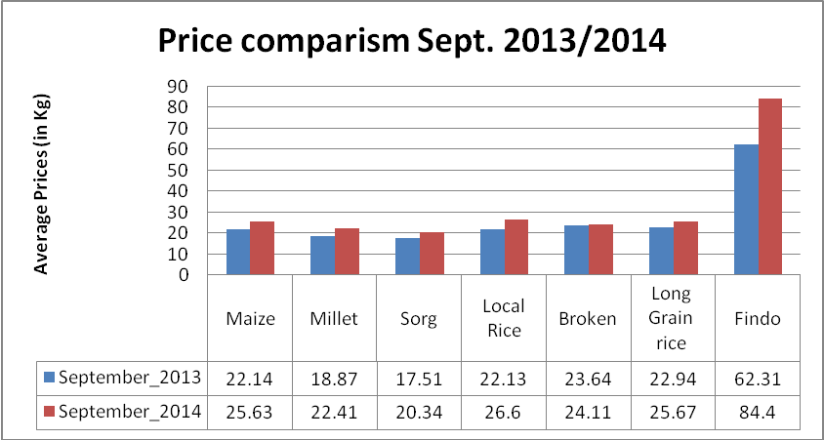

In general imported rice showed an upward trend both at the retail and semi-wholesale markets. The price remained relatively high compared to 2013 when it shifted from 950 to 1050 representing a 10.5% variation from that of September 2013.

Coarse grain price
Coarse grain prices stabilize but remain high; with maize price the highest
The prices of major coarse grains are steadily increasing. Maize price stands at 25.63, millet 22.46 and sorghum 21.84 Dalasis as at 3rd week of September 2014, while last year at the same period it stood at 22.14, 18.87, and 17.51 Dalasi per kilo respectively. In price differences maize: 15% , millet: 18% and sorghum: 16% were observed over the period. The overall coarse grain prices have slightly moved upward over the period but remained steady though, with variation of D3.2 per kilogram.

4.2 CROP PROTECTION

4.3 LIVESTOCK
N/A

4.4 FISHERIES
N/A

5.0 NATIONAL DISASTER MANAGEMENT AGENCY (NDMA)
N/A

6.0 NATIONAL ENVIRONMENT AGENCY (NEA)
N/A

Banjul September 25th 2014
National MWG of The Gambia

Composition of MWG:  Department of Water Resources  Planning Services - Department of Agriculture (DOA)  Communication, Extension & Education Services - DOA  Animal Health & Production Services - DOA  Plant Protection Services - DOA  National Environment Agency | Direct your comments and questions to:  The Director  Department of Water Resources  7 Marina Parade, Banjul  The Gambia  Tel: (+ 220) 422 76 31 / 422 41 22 / 890 52 29  Email: dwr@mofwrnam.gov.gm

